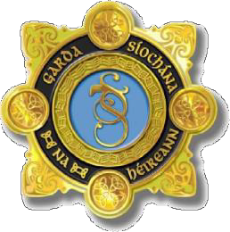
AN GARDA SÍOCHÁNA NATIONAL VETTING BUREAU

PARENT/GUARDIAN CONSENT FORM (NVB 3)

Applicant Details

Forename(s): Surname:
 |  | / |  |  | /

Date Of Birth:

Parent/Guardian Details

Under Sec 26(b) of the National Vetting Bureau (Children and Vulnerable Persons) Acts 2012 to 2016, it is an offence to make a false statement for the purpose of obtaining a vetting disclosure.

Forename(s): Surname:
 |  |  |  |  |  |  |  |  |  |  |  |  |  |  |  | Mother: |  |  |  |  | Guardian:

Relationship to applicant: Father:

Contact Number: Email Address:

Address:

Line 1: Line 2: Line 3: Line 4: Line 5: Eircode/

Postcode:

Parent/Guardian Consent

I, being the Parent/Guardian of the above named applicant, consent for the National Vetting Bureau to conduct vetting in respect of the above named applicant in accordance with the National Vetting Bureau (Children and Vulnerable Persons) Acts 2012 to 2016.

Parent/Guardian
Signature:
Date:

/ /

