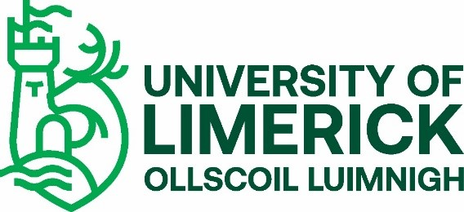
INTERNATIONAL STUDENT VETTING REQUIREMENTS 2023
The University of Limerick (UL) offers undergraduate and taught postgraduate educational and training programmes that require students to undertake placements with external agencies. Such placements may bring the students into contact with children and vulnerable adults and require them to assume positions of trust. To ensure the protection of the public and justify public trust and confidence, UL is committed to ensuring that only suitable candidates are allowed to undertake these programmes.
In accordance with the National Vetting Bureau Acts 2012-2016 and UL’s Student Vetting Policy, there is a statutory requirement for all students on programmes that include a placement involving work with children or vulnerable adults to be vetted.
If your programme is on the list of UL Programmes with a Vetting Requirement, you should now go to the UL Student Vetting website, https://www.ul.ie/provost/functions-processes/student-vetting, and print off the documents in the Student Vetting for International Students section.
You should then:
- Complete a Vetting Invitation Form (NVB 1) in accordance with the Guidelines for Completing Vetting Invitation Form (NVB 1). (EVetting Tutorial Video available on Student Vetting website may help you).
- Complete UL Photographic Identity Certification Form (2) to include a scan/photocopy of the relevant document image (driving license (credit card size) or national ID card and take the form and original ID to be certified by one of the approved certifiers listed on the form.
- Submit an original Police Clearance Certificate/Criminal History Check from every country you have lived in for more than six months since reaching 16 years of age. (For the United States, an FBI national check must be submitted.) International Police Clearance certification should check for criminality and, where possible, clear you to work with children and vulnerable adults. Please apply for this certification as soon as possible as it can be a lengthy process.
- Submit Proof of Current Address document. Such as Utility Bill/Bank Statement (dated within last 6 months). Mobile phone/Car Insurance statements not acceptable. More details at https://vetting.garda.ie/Help/FAQ in the Verification of Identity Section.
- Once you are in Ireland, you will be required to schedule a meeting with a Peace Commissioner/Solicitor to sign a Sworn Affidavit.
- If under 18 years of age, you will need to submit a Parent/Guardian Consent Form (NVB 3) completed by your parent/guardian.
Form Submission – Original Hard Copy Documents Only to Be Submitted (scans/photocopies not accepted)
Please keep a copy for yourself and either post all original vetting documents to the CDV Unit, Main Building, University of Limerick, Castletroy, Limerick V94 T9PX or, if on campus, please submit them to the UL Student Vetting Dropbox in the Foyer of Main UL Reception. You may wish to use tracked post where important documents are being submitted. If you are awaiting a Police Clearance Certificate, this can be submitted separately after your initial documents have been submitted.
E-Vetting
After you have submitted your hard-copy original vetting forms and they have been processed by UL, you will receive an email from the National Vetting Bureau (evetting@donotreply@garda.ie) with a link to a full online vetting application form, which you must complete within 30 days or it will expire and you will have to start the vetting process again.
Please Note
Full details of any convictions or criminal prosecutions (past or pending) must be included on the online application form. It is imperative that no false information be furnished. Failure to provide full details may result in you not being able to undertake your practice placement. Where issues arise around clearance, you will be contacted by either the National Vetting Bureau or the UL Liaison Person.
Confirmation of Vetting Process
You will receive several automated emails during your vetting process: one from UL when your vetting application form has been received and processed, another from UL if you need to submit any outstanding documents, a number from the National Vetting Bureau while your online e-vetting application form is being processed and a final one from UL when your UL vetting process is complete.
Confirmation of vetting for your placement is provided by your Course Director, who should be asked to supply you with a UL Vetting Confirmation Placement Agreement Form (available on the Student Vetting website).
Please note that your registration remains provisional until you have successfully completed the vetting process.
Further details on the UL Student Vetting process can be found at: https://www.ul.ie/provost/functions-processes/student-vetting
If you cannot find the answer to your query on the website, the UL CDV Unit can be contacted at: ULStudentvetting@ul.ie
_________________________________________________________________________________
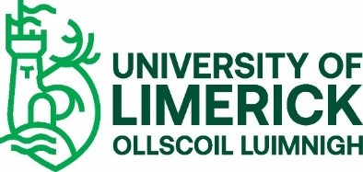
INTERNATIONAL STUDENT VETTING CHECK LIST (not to be returned)
Please ensure that you submit the following relevant documents as prescribed on the form.
Essential
- Vetting Invitation Form (NVB 1)
- UL Photographic Identity Certification Form (2) signed by a prescribed certifier as listed on the form
- Proof of Current Address document: Utility Bill/Bank Statement (produced within 6 months. Mobile phone/Car insurance statements not acceptable)
- Police Clearance Certificates from every country you have lived in for more than six months since reaching 16 years of age (can be submitted after NVB1 and Photo ID 2 forms)
- Signed Sworn Affidavit – ONLY required if you are an International non-EU student. (To be arranged and submitted once you are in Ireland).

Additional, if relevant:
- Parent/Guardian Consent Form (NVB 3) – ONLY if you are under 18 years of age

