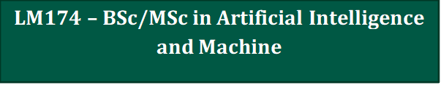
Application information for mature student applicants
Apply through CAO by 1st February  www.cao.ie | Please refer to Academic Registry for late applications.

Application Process:
- CAO application form – Applicants must ensure that they tick the ‘mature’ special category on the CAO application form and complete Sections 1 to 11 of the Mature Applicant section.
- Personal Statement for LM174 – Course Directors use personal statements to help them more effectively assess an applicant’s suitability for and level of interest in a particular course. See the guidelines overleaf for writing a personal statement for ‘LM174’. The Personal Statement requirement is to enable you to provide more specific information than that which is provided in the ‘Statement of Interest’ on your CAO form
- Supporting documentation – All supporting documentation (e.g., evidence of prior qualifications, Personal Statement for LM174, etc.) should be posted directly to the CAO.

Minimum Entry Requirements:

H3 in Leaving Certificate Mathematics.
OR
A Distinction in QQI Maths for STEM (5S2246/5N0556) as this is equivalent to an H3.

Application Assessment Criteria:
• It must be clear from the application form and personal statement that the applicant is interested in the course.

Interview Assessment Criteria:
Interviews may be considered for applicants who do not meet the minimum entry requirements stated above to assess the following:
• Interest in the programme
• Aptitude for programme
• Numerical skills

Guidelines for writing a Personal Statement for LM174:
The Personal Statement is your opportunity to 'sell' yourself and to emphasise the experience and/or interests you have which are relevant to the course for which you are applying. A tailored personal statement is important when there is a high demand for places. You will need to be specific and proactively demonstrate how your experience or your interests make you a good candidate for the course
Your personal statement should be no greater than one side of a single A4 page and cover the following areas:
- Reasons for wishing to undertake LM174
- Programme's potential contribution to your future career or life plans
- Highlight relevant experiences or skills gained through employment, voluntary work, or personal interests which have prepared you to undertake LM174.
- Your knowledge and understanding of the career area in which you are interested
- Any specific preparation you have undertaken in anticipation of commencing LM174.
• Please title your document ‘Personal Statement for LM174 and include your CAO number on your Personal Statement

