MSc Applied Sports Coaching Application
Additional Documentation
Version for Candidates Starting September 2024

Overview
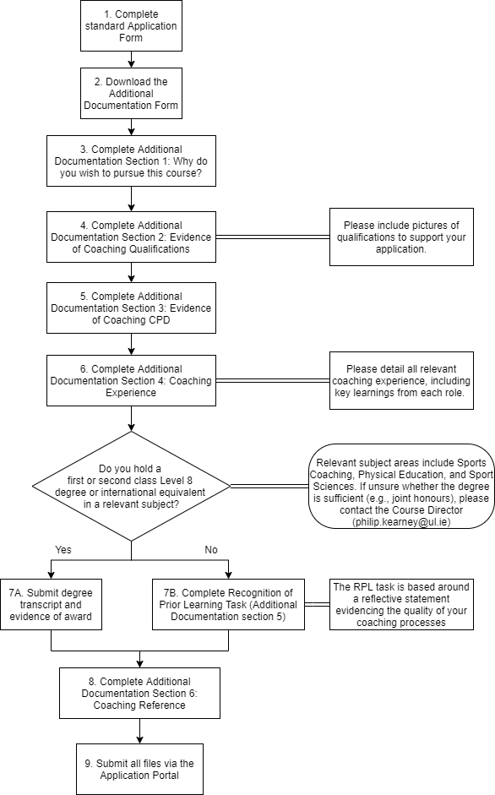
Section 1. Why do you wish to pursue this course? [All applicants]
(guideline 500 words)
While your main application form contained a brief section on this question, here we wish to see a more detailed rationale for your pursing this particular course at this moment in time. Specifically, please detail (a) how this course may contribute to your personal and professional development, and (b) why you feel that you have the breadth and depth of coaching experience to make the most of the programme. As part of the latter, please describe what you currently find/have found in the past to be most effective in enhancing your development as a coach.

Section 2. Evidence of Coaching Qualifications [All applicants]
Please complete this table indicating all coaching qualifications that you hold. Coaching qualifications from a range of different sports, and coach tutor/coach developer qualifications are also relevant and should be described here.
COACHING QUALIFICATIONS
Award | Date

Please either:
- Insert pictures in this section corresponding to each of the awards listed above (example below), or
- When completing the online application form, upload additional document(s) containing photocopies of all coaching qualifications mentioned here.

Example of Evidencing Coaching Certificates/Qualifications
Simply paste in pictures of your certificates into this section, or, when completing the online application form, upload additional document(s) containing photocopies of all coaching qualifications mentioned here. If you do include a large number of pictures, it would be best to save this document as a PDF file prior to submitting.
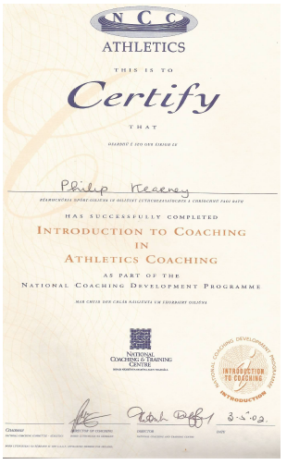
Example of inserted certificate via Insert > Pictures

Section 3. Evidence of Coaching CPD [All applicants]
Please complete this table indicating all coaching continuous professional development (CPD) that you have completed over the past three years.
CPD includes primarily courses and workshops (run by your National Governing Body or another body), online courses, etc.
If you have not attended much formal CPD, you might supplement this list by identifying key alternative resources that you have engaged with (e.g., Books: list 3-5 key books that have influenced your coaching; Podcasts: list 3-5 key podcasts that have influenced your coaching). In essence, we wish to know what you currently do to develop your knowledge and your coaching practice.

COACHING CPD ATTENDED OVER THE PAST THREE YEARS
CPD / Workshop (title and venue) | Date

Section 4. Documentation of Coaching Experience [All applicants]
Please describe your coaching experience including dates, club/educational establishment, contact, a brief description of athletes/players and your role, and the key learning that you took from this experience (one line).
We are using this form to evaluate your breadth of coaching experience. Breadth of coaching experience refers working with differing populations (e.g., younger and older athletes), different forms of the game (e.g., 7s and 15s rugby), or with different sports. Coach tutoring or mentoring would be considered to contribute to breadth of coaching experiences (coaching coaches).
To enhance their application, former elite players will be encouraged to consider and provide details on how they may have acted as a leader or mentor as a player (e.g., supporting younger players).

Example description of coaching experience
Dates: 2010-2015
Organization: Forest Green Athletics Club
Contact: secretary@forestgreenathletics.ie
Athletes and Role: Head coach (throws), responsible for the design and implementation of training sessions and management of competitions for 12 athletes ranging from U17 to Senior level who competed at local, regional and national level.
Key Learning: Managing the transition of young athletes from junior to senior, especially considering the role of senior athletes in facilitating this transition.

COACHING EXPERIENCE
Dates:

Organization:

Contact:

Athletes and Role:

Key Learning:

Dates:

Organization:

Contact:

Athletes and Role:

Key Learning:

Dates:

Organization:

Contact:

Athletes and Role:

Key Learning:

Dates:

Organization:

Contact:

Athletes and Role:

Key Learning:

Dates:

Organization:

Contact:

Athletes and Role:

Key Learning:

Dates:

Organization:

Contact:

Athletes and Role:

Key Learning:

Section 5. Application Route [All applicants]
If you hold a first or second class Level 8 degree or international equivalent in a relevant subject, then you have completed all necessary sections of this form. Please save this form as a word or pdf document, and upload it with your primary application form.
ROUTE 1
Candidate holds a primary degree*
*Relevant subject areas include Sports Coaching, Physical Education, and Sport & Exercise Sciences. If unsure whether the degree is sufficient (e.g., joint honours), please contact the Course Director (philip.kearney@ul.ie)

ROUTE 2
Recognition of Prior Learning

If you do not hold a first or second class Level 8 degree or international equivalent in a relevant subject, then please complete Section 6. Recognition of Prior Learning (RPL) Application drawing upon your coaching experiences. Further information on applying via RPL is provided below.

Additional information for applicants to the MSc Applied Sports Coaching who do not hold a primary degree in a related area
Graduate programmes normally require a minimum academic qualification at primary degree level. It is recognised that learning can and does occur outside of traditional routes. The Department of Physical Education and Sport Sciences is committed to the principles of equity and accessibility and facilitates entry to programmes through non-traditional routes. Applicants who do not meet the normal academic requirements (Level 8 Honours degree in a relevant subject) may apply to have prior learning considered. The University is committed to recognising prior learning (RPL). In applying RPL, the university will be cognisant of the need to ensure that the integrity of its awards is rigorously guarded and that academic standards are maintained. Applicants need to be aware that these programmes require a high level of commitment of time and study. Academic writing, science and computer skills are required for this programme.

Recognition of Prior Learning (RPL)
RPL is an assessment process to determine the extent of the achievement of an applicant of the learning outcomes, competency or standards’ for entry into completion of a programme of study. The prior learning may have been acquired by formal non-formal or informal routes.
In assessing the supporting statement assessors will require a reflective learning statement identifying the learning. Assessors will take due regard to professional and statutory accredited study.
Applications are very individual and should focus on demonstrating the learning you have achieved. The recognition of prior learning is intended to provide you with the opportunity to demonstrate that you can perform adequately within the context of higher level academic programmes.

Applications are considered under the following criteria:
Standard: Are the learning, knowledge, skills and achievements demonstrated through the evidence at an acceptable level?
Sufficiency: Is there sufficient evidence to support your claim?
Validity: Does the evidence support your claim?
Relevance: Is the learning demonstrated through the evidence relevant to the target programme of study you are applying for? This means that it will be considered in the context of the learning outcomes of the programme.
Currency: Is the learning current, or if not, is there evidence of appropriate updating?
Authenticity: Is the evidence genuine, and clearly defended as your own achievement?

For further information on the RPL process please contact:

Postgraduate Admissions
Graduate School
2nd Floor, Foundation Building
University of Limerick
Limerick
Ireland
Tel. +353-61-234377
Fax. +353-61-233287
postgradadmissions@ul.ie

Alternatively, contact the MSc Applied Sports Coaching Course Director:

Phil Kearney PhD
Department of Physical Education & Sport Sciences
University of Limerick
Ireland
Tel: +353-61202844
Email: philip.kearney@ul.ie

Recognition of Prior Learning: Reflective Statement [Route 2 applicants only]
(do not exceed 1500 words)
Provide a detailed account of one experience from your coaching practice that you believe had an important influence on why you coach the way you coach. It is particularly important that you explain what you learned through this experience.
If it helps, you may think of this as a mini-case study. Explain what happened (ensuring anonymity), and then unpack why you think the incident happened, what the consequences were for you and others, whether you could have done anything differently, and what lessons you will take for the future. The incident can be a challenge that you were unable to solve at the time, or something that went really well and you wish to solidify the lessons for future.

Reference
Please provide a reference statement in support of your application from someone with appropriate knowledge of your coaching skills. The reference can be in any format. Example guiding questions are provided below.
If supplied in a word document, the reference can be inserted here. Alternatively, if supplied as a pdf, the document may be uploaded as a distinct document.

Sample Referee Questions
- How long have you known the applicant and in what capacity?

- Please comment on the candidate’s coaching.

- The qualities of initiative, application and independence are critical when pursuing a postgraduate degree. Please comment on whether you feel the applicant possesses these qualities.

