**User Guide: How to Use Manager Requests on CoreHR Portal**

**Introduction**

**Manager Requests** allows managers to submit sick leave requests on behalf of their team members. The types of sick leave requests managed in this section include **Certified Sick Leave** and **Uncertified Sick Leave**. This guide will walk you through how to use the **Manager Requests** feature to handle these requests efficiently.

**Table of Contents**

1. **Accessing the CoreHR Portal**
2. **Navigating to Manager Requests**
3. **Types of Sick Leave Requests**
4. **Reviewing and Managing Requests**
5. **Approving or Rejecting Requests**
6. **Notifications and Updates**
7. **FAQs**

**1. Accessing the CoreHR Portal**

To begin using the **CoreHR Portal**:

1. Open your web browser.
2. Enter the **CoreHR Portal URL**: [Login | People XD (28.0.116)](https://my.corehr.com/pls/coreportal_esbsheulp/cp_por_public_main_page.display_login_page)
3. Log in using your **Username (firstname.lastname)** and **Password (Same as UL Email and Desktop Password)**.

Once logged in, you'll be directed to the CoreHR Portal's homepage.

**2. Navigating to Manager Requests**

To access the **Manager Requests** section where you can manage sick leave requests:

1. On the **Manager Dashboard**, locate the **Manager Requests** widget on the **My Team** section from themenu on the left.

**3. Types of Sick Leave Requests**

In the **Manager Requests** section, you will manage two types of sick leave requests submitted by employees:

* **Certified Sick Leave**: This is a request for sick leave for 3 or more days supported by a medical certificate from a healthcare provider. The manager must attach the certificate or proof of illness when submitting the request.
* **Uncertified Sick Leave**: This is a request for sick leave no greater than 2 days where no medical certificate is required. The employee may report their illness, but no medical documentation is required.

**4. Submitting a Requests**

1. On the **Manager Dashboard**, locate the **Manager Requests** widget on the **My Team** section from themenu on the left.
2. Click **Create Request.**

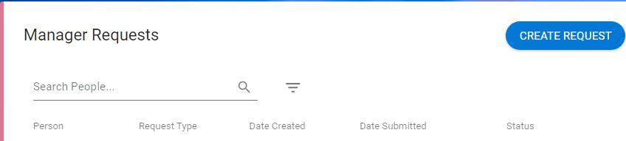

1. **Select the employee** from the Drop-down menu.
2. **Then select the request type from the Request Type Drop Down**

* + For **Certified Sick Leave**, you will need to upload a doctor’s certificate. To add this, click the Upload button on the top right of the screen.

* + For **Uncertified Sick Leave**, the request will show the employee’s reported illness, and the dates of leave requested.

**6. Notifications and Updates**

Once you act on a sick leave request, notifications are automatically sent to both you and the employee. Here's what to expect:

* **Approval Notification**: The manager will receive a notification confirming the approval of their employee’s sick leave request.
* **Rejection Notification**: If a request is rejected, the manager will be notified with an explanation (if provided) and the next steps (if applicable).

**7. FAQs**

**1. What if I need more information from an employee about their sick leave?**

* If additional information or documentation is needed (e.g., for uncertified sick leave), you can request the employee to provide the required documents.

**2. Can I approve or reject multiple sick leave requests at once?**

* Currently, you can only approve or reject requests individually, but the portal provides an easy navigation system to handle each request quickly.

**3. What if an employee submits a sick leave request without a medical certificate?**

* For **Uncertified Sick Leave**, the request may be approved depending on your company's policy. However, if the request is for **Certified Sick Leave** and no medical certificate is attached, the request will be rejected. The manager should ask the employee to submit the necessary documentation before re-submission.

**4. Can I modify a sick leave request after I approve it?**

* Once a sick leave request is approved or rejected, the status cannot be changed directly. If you need to modify a request, you should contact HR or ask the employee to submit a new request with the correct information.

**5. How far in advance should I approve sick leave requests?**

* It’s best to approve sick leave requests as soon as possible to ensure the employee's absence is accurately reflected in scheduling or payroll. For uncertified leave, if it's urgent or for short durations, you may approve it pending further documentation.

For any further questions or assistance, don’t hesitate to contact HR [compandbens@ul.ie](mailto:compandbens@ul.ie) .