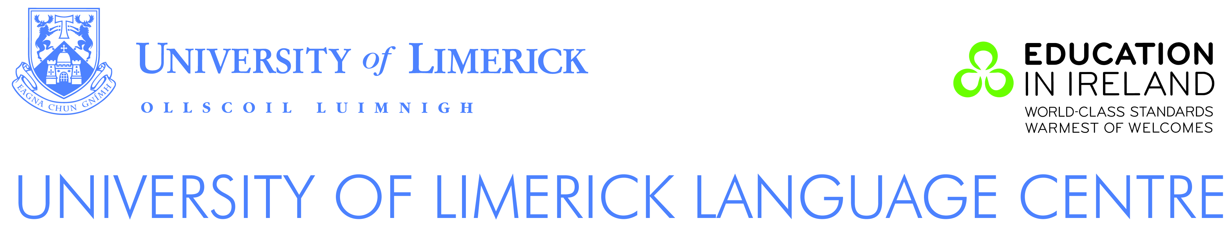

Proposal

Language and Culture

2 Week Intensive General English + Irish Culture Programme

Josai University
Japan

Group size: 10 students minimum
February 2016 (Exact dates to be confirmed)

Introduction

Our General English course will give the students the opportunity to use all language skills with more intensive practice in speaking and listening. The emphasis is on developing fluency and on learning to communicate effectively in English. Communicative activities and tasks include group work, role-playing, language games and problem solving. Themes relating to Irish culture will also be covered.

Students will be integrated with other Language Centre students. On day one of their course, students will be given a placement test in order to determine their English language level and the most appropriate class for them.

Course outcomes for General English
It is expected that
- participants will have acquired speaking, listening, reading and writing skills appropriate to their level which can be used in a variety of familiar and some non-familiar areas;
- participants will have extended their vocabulary relating to everyday activities and other themes;
- participants will have developed their communication skills;
- participants will have developed autonomous learning skills;
- participants will have extended their knowledge of Irish culture.

Summary of Costs

Description | Per student
1. Tuition
2 weeks x 20 contact hours General English +  2 weeks x 2 afternoons of Irish culture | €500
2. Homestay Accommodation
@ €175 per student per week | €350
3. Homestay Placement Fee | €30
4. Additional activities:  Four half day activities – Limerick city tour;  Irish language class; Irish dancing;  One school visit | €50
5. Full-Day Excursion to a place of interest | €50
6. Group Administration Fee | €50
7. Return Airport Transfer – Dublin | €50

Included in Tuition Fees
- tuition from highly qualified and experienced teachers
- free textbook and/or learning materials
- free access to Internet in custom designed learning space
- free access to the Language Resource Area and library
- access to many university facilities (at a much reduced cost) including the university sports arena and 50m swimming pool
- University of Limerick certificate on successful completion of course

Homestay Accommodation

Accommodation will be organised with local host families. Homestay accommodation includes full board (all meals), including packed lunches on weekdays. Homestay accommodation allows students to experience life with an Irish family and gives the maximum opportunity to practise their English.

The students will be accommodated individually with host families unless a special request is made to allocate 2 students to one family.

Insurance

Insurance is the responsibility of the sponsors/course participants. All participants are strongly advised to take out medical and travel insurance.

