
RESEARCH PERFORMANCE AND CAREER DEVELOPMENT PLAN

UNIVERSITY OF LIMERICK

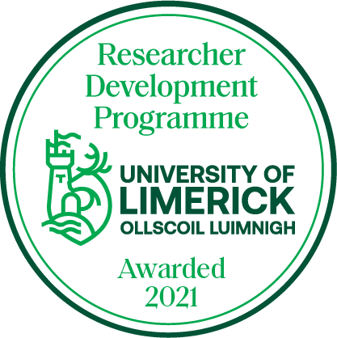

- Use this form as the basis for deciding which training modules to use for your development from the Researcher Development Website

- Review this form regularly to make sure you are progressing against your objectives.

- You may discuss this in your review with your PI.



Personal Details:

Name |  | Job Title |  |  | Staff Number:
Dept/ Unit: |  | Faculty |  | Review Period | From | To:

SECTION 1. CAREER OBJECTIVES.
Short-Term Career Objectives (Year 1):
Using the indicators in the table below, please identify your short-term career objectives 1.
1. Research Activities
a)
b)
c)

2. Research Outputs
a)
b)
c)

3. Skill Development (see skills audit in Section 2)
a)
b)
c)

4. Other objectives
a)
b)
c)

Long-Term Career Objectives (Next 5 years):
This section should reflect your career aims beyond your current role.

Section 2: Skills Audit
Skills Audit
This skills audit should be used to inform what development programmes you wish to choose from the Researcher Development programme menu.
Vitae RDF Domain | Topic | Development Need  (1=no requirement for development;  5 = strong requirement for development)
Domain A: Knowledge and Intellectual Abilities
 |  | 1 | 2 | 3 | 4 | 5 | Comments
Research Methods
Information Seeking
Critical Thinking, Problem Solving
Creativity, Innovation
Domain B: Personal Effectiveness
Personal qualities, confidence, self-reflection
Planning, prioritising, time management
Professional and career management, networking, building reputation
Domain C: Research Governance and Organisation
Funding generation
Financial management
Developing a research strategy
Professional conduct: Ethics, legal requirements, IP, authorship
Domain D: Engagement Influence and Impact
Engagement and impact
Communication and dissemination
Teamwork
Influence and leadership

Section 3: Individual Objectives for Next 12 Months

Key Areas of your Job | Objectives | By When | Progress/Achievements

SECTION 1 OF FORM TO BE HELD JOINTLY BY JOB HOLDER AND MANAGER

Section 4: Individual Development Objectives
Referring back to the Career Planning (Section 1) and your Skills Audit (Section 2), what are your individual development objectives for the next 18 months. This should include both identifying which ten (minimum) programmes you wish to undertake from the Research Development Programme menu, as well as any other development opportunities. Other development opportunities could include, for example, shadowing colleagues, networking internally/externally, involvement with PI on particular aspects of the research, etc.
Development Objectives | Development Action(s) | By When | Progress/Achievements
Knowledge and Intellectual Abilities

Personal Effectiveness

Research Governance and Organisation

Engagement, Influence and Impact

SECTION 4 OF FORM TO BE HELD JOINTLY BY JOB HOLDER AND MANAGER. A summary of any formal training needs identified to be forwarded to the Dean/Division Head and the Learning and Development Unit (hrtalentdevelopment@ul.ie).

Signed:________________________________(Job Holder). Date:_________________
_________________________________(Manager) Date:_________________

