Add alternative/additional security method (SMS/Call).
- Go to https://mysignins.microsoft.com/security-info and click “Add method”.
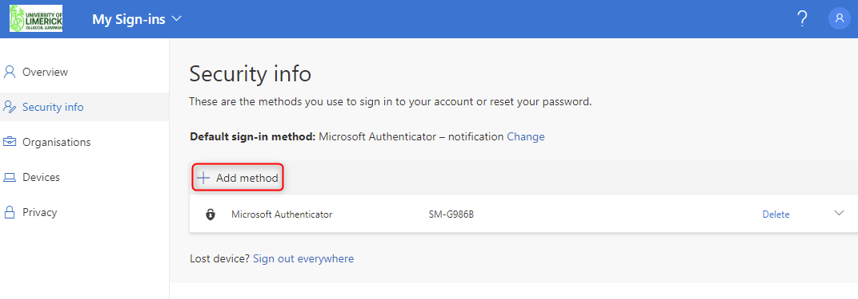
- Select the method you would like to add. e.g. Phone, Authenticator
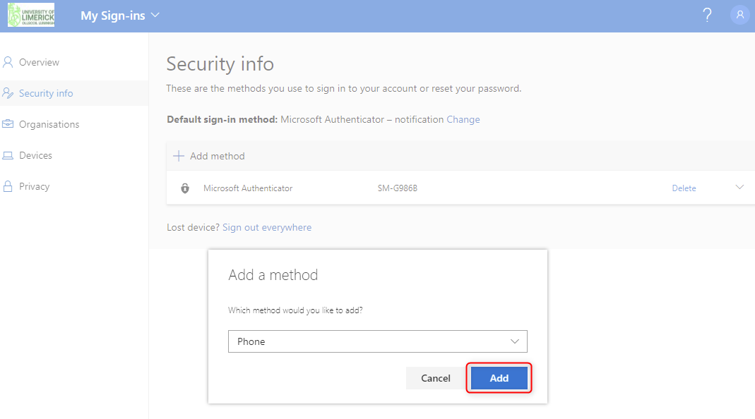

- Enter your country code and mobile number. Select “Text me a code” or “Call Me”.
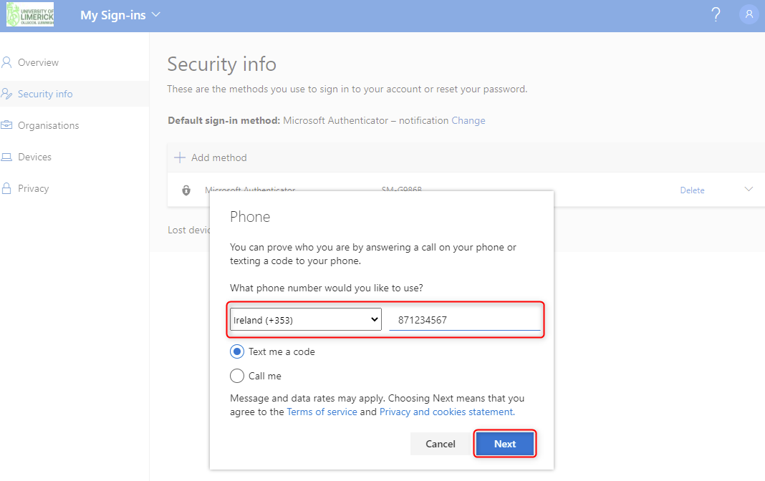
- You will receive a verification code via SMS/Call.
Enter the code and click Next.
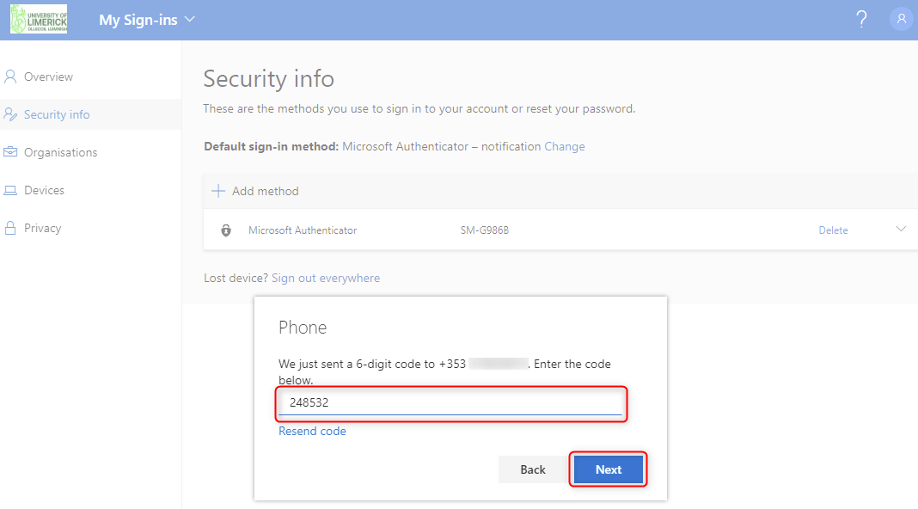

- You have successfully added an additional security method.

Add alternative/additional security method (Authenticator App).
Install the Microsoft authenticator app on your Android/iOS device.
- Go to https://mysignins.microsoft.com/security-info and click “Add method”.
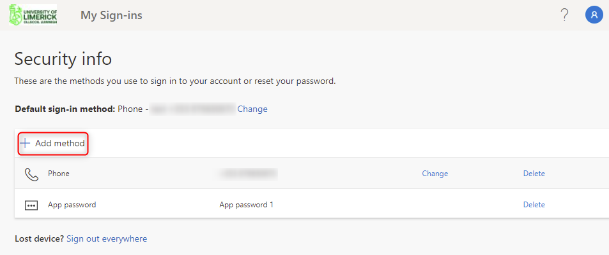
- Select Authenticator app and Click “Add”.
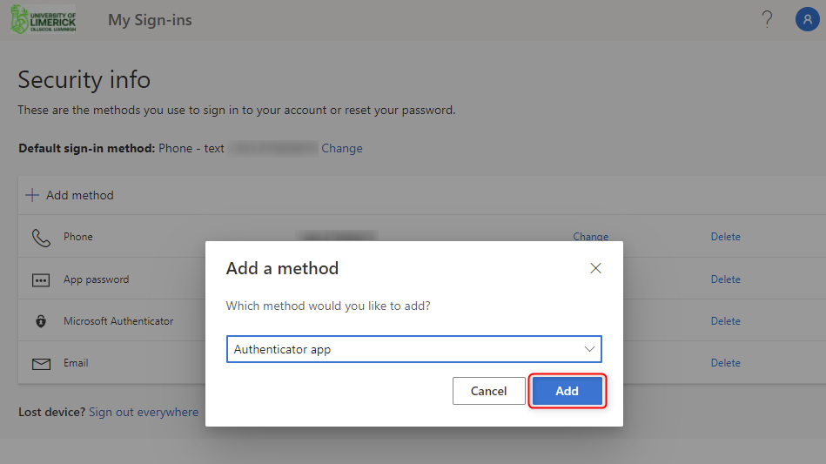
- Click “Next”.
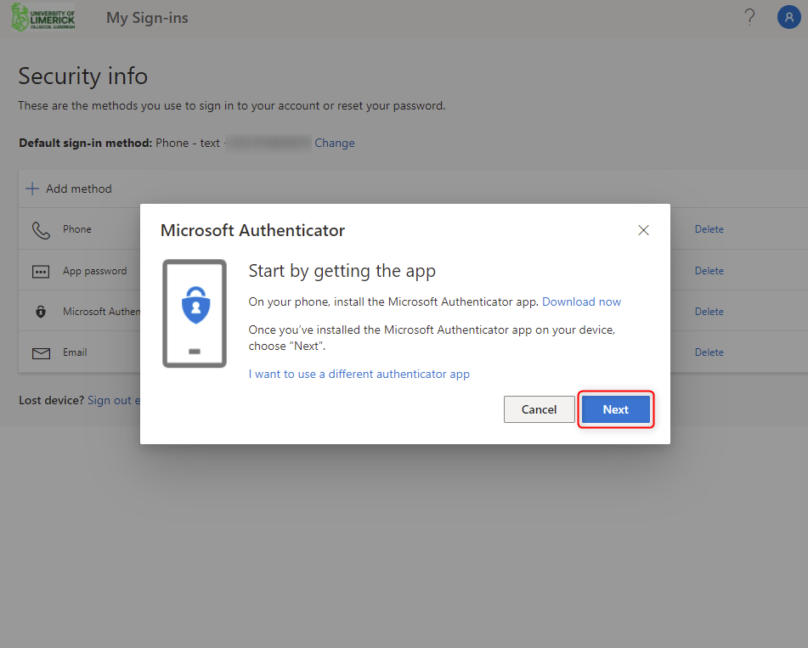
- Click “Next”.
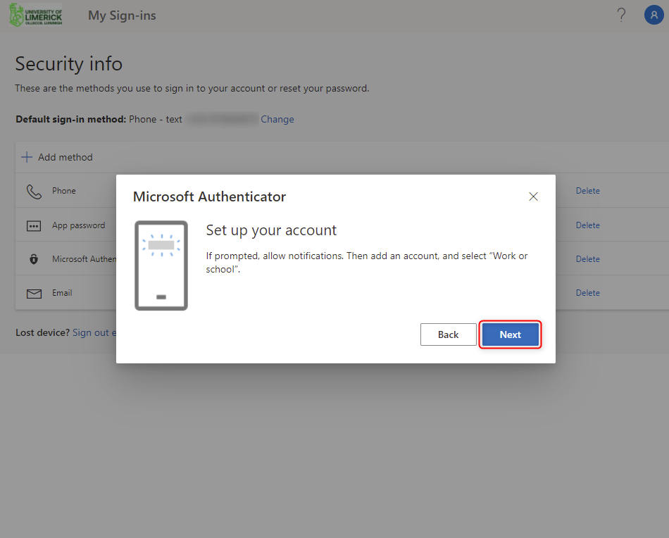
- Open the authenticator app and add a new work or school account. Click QR code.

Scan the QR code on screen with the authenticator app.
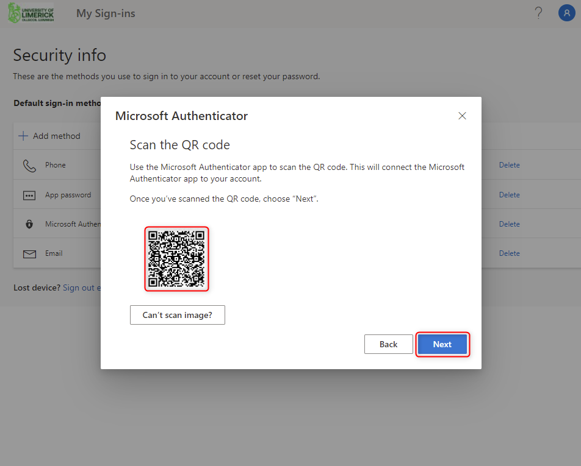

- Approve the notification pop up in the authenticator app. Then click “Next”.
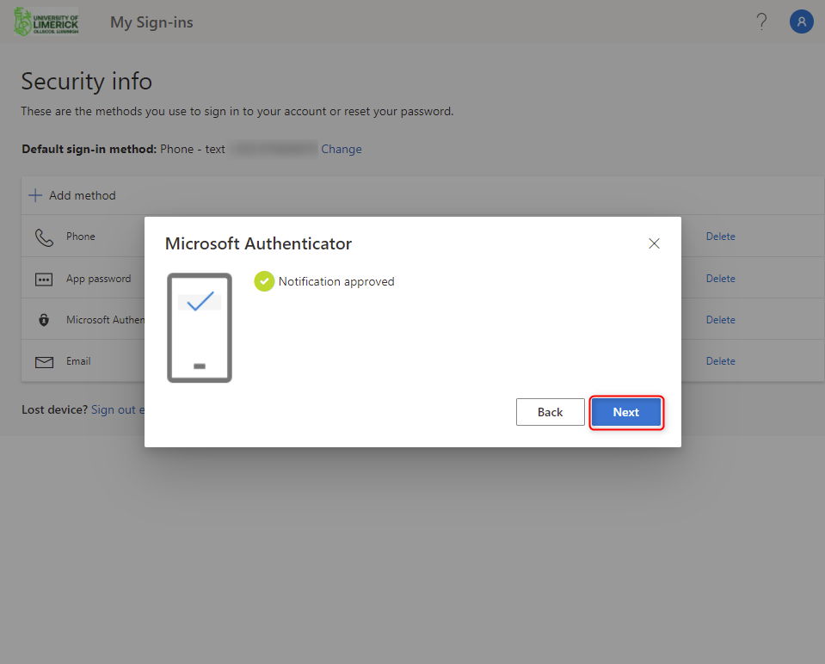
You’ve successfully setup the authenticator app.

