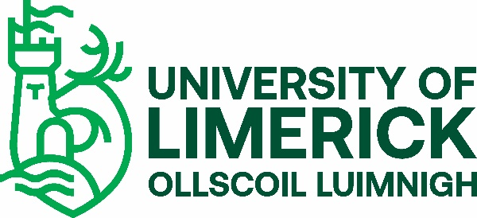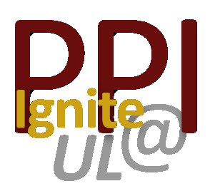
PPI Ignite Network@UL bursary scheme 2023/24 - information sheet

Introduction

In 2017, the Health Research Board and Irish Research Council funded a 3-year pilot programme through the PPI Ignite Awards, aimed at advancing public and patient involvement in health research. In 2021, a further 5 years of funding was given to 7 Irish universities to develop a PPI Ignite Network and to embed PPI in health research locally and nationally.
https://www.ul.ie/hri/themes/public-and-patient-involvement-ppi
In order to support public and patient involvement in health research at UL, the PPI Ignite Network@UL will fund up to 3 bursaries for UL Researchers and PhD students in 2023/2024. Applications are invited from researchers to support partnerships with community and/or patient organisations. The bursaries can be used to establish new partnerships or to develop existing ones. Examples include but are not confined to activities that:
- develop PPI networks and partnerships through meetings or events to develop research priorities
- support engaged research to enhance recruitment, fieldwork, dissemination
- promote PPI education and training
- develop tools and resources
- raise awareness and improve communication about PPI in health research

Eligibility
Each application must have a UL researcher or a UL PhD candidate as the main applicant, and at least one community partner. In the case of an application from a registered PhD candidate as the main applicant, it must have at least one community partner and one UL academic/researcher (e.g. PhD supervisor). One of the applicant’s team must be employed by UL for the duration of the work and assume responsibility for administering and reporting on the budget between October 23 and April 2024. Please note that PhD students cannot be cost code owners.
Applications can be made by existing partnerships or those wishing to begin a partnership.
Funding: Bursaries are for a maximum of €2,000 each. 3 x €2000 bursaries are available in 2023/24
Timeline:
Launch of the scheme: 3rd April 2023
Deadline for applications: 30th June 2023
Results: September 2023
Work to take place: October 2023 – April 2024
Summary of activity and finance report due: 16th June 2024
General info for successful awardees:

Successful awardees may be requested to participate in a seminar/workshop highlighting the outcome and impact of projects (post-project close).
PPI Ignite Network @ UL must be acknowledged on all project outputs and communications.

Application process
Completed application forms to PPI-ignite@ul.ie by 30th June 2023
Applications will be marked on the following criteria:
- Quality of the proposal (well thought-out idea)
- Feasibility (realistic timeframe, accurate budget)
- Communication strategy
- Clear articulation of likely impact/outcomes on PPI in health research

