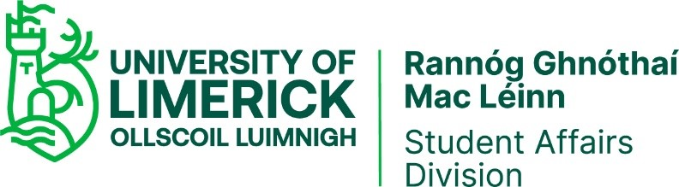

Arts Office Key Business Process

PURPOSE
The purpose of this process is to describe the main procedures associated with the delivery of key services and activities of the UL Arts Office.

RESPONSIBILITY

The UL Arts Officer is responsible for this process. The UL Arts Officer is responsible for implementing the associated procedures.

PROCEDURE

The UL Arts Office develops a programme of events during the calendar year to promote the arts amongst the UL community. The programme of events changes annually and supports the university’s strategic plan in the areas of community engagement. Activities are supported by robust planning and include the development of educational resources and opportunities and a focus on utilising the university’s art collections in the delivery of same. The primary procedures associated with the delivery of the above include
- Event Development and Management
- Facilitation of the University Community and Outside Groups
- UL Clubs & Societies Executive membership

Event Development and Management
The Arts Office develops an event. Events are typically:
- Arts Office unique production
- Collaborative event in association with University partner in academic and support divisions
- Curation of exhibitions and supporting visitor programmes for university Visual Arts Office
- Collaborative event in association with an external partner for example community based project
The development and management of each event is determined by nature of the event for example an external agency coming into the University may require organisational involvement by the Arts Office. An internal collaborative project will vary depending on the extent of the Arts Office’s involvement which can range from simple sponsorship to an almost complete responsibility for bringing the event to a satisfactory conclusion. Most of these events are originated and developed by the Arts Office. The Arts Office is in receipt of a budget which it centrally administers. Each event is ascribed a budget.

- Develop and Identify Event Type
- Identify Event partners/collaborators if applicable
- Create Event Timeline
- Create Action Plan
- Determine Arts Office budget allocation
- Advertise event using university communications platforms and initiate social media campaigns# 7. Invite stakeholders and potential audience
- Initiate Action Plan Arts Office
- Event
- Analyse and Review
- Carry out second phase event where applicable
Facilitation of the University Community and Outside Groups
UL Arts Office will respond to and liaise with members of its own community and outside groups where the occasion arises. This may be simply a response to a query regarding an event, not necessarily Arts Office originated; advertisement of upcoming events; assistance financial and advisory
- Identify Event type
- Determine nature of Arts Office involvement and level of responsibility
- Identify Event partners/collaborator
- Allocate budget
- Create Event Timeline
- Create Action Plan
- Allocate Action Items to partners
- Undertake Action Items
- Review Event

UL Clubs & Societies Executive membership
- Attend C&S Executive meetings
- Follow up on any actions arising from meeting
- Advise Executive in relation to matters to be presented to C&S Council at their bi-weekly meetings
- Adjudicate any disputes that may arise within individual Clubs & Societies
The Arts Office also has a key role in supporting and promoting the work of individual student Clubs and Societies. The majority of this support is developmental. The Office also selects the recipient of the annual Mike Sadlier honorary award recognises the outstanding work of an individual’s contribution to student societies during their time in UL

DOCUMENTATION
N/A

RECORDS

Records are held by UL Arts Office for the period defined by individual processes. All members of staff operate in accordance with the University’s Records Management and Retention Policy. Any personal data that is used as part of this process is processed in accordance with the General Data Protection Regulation (GDPR) / Data Protection Acts 1988-2018 and the University of Limerick Data Protection Policy.

PROCESS VERIFICATION

Events organised by the UL Arts Office are self-assessed on an annual basis. These assessments are broadly qualitative. Feedback is gathered via workshop questionnaires, Qualtrics surveys

REVISION HISTORY

Revision No. | Date | Approved by: | Details of Change | Process Owner
1 | October 2013 | Quality Team | Initial Release | Arts Officer
2 | March 2023 | Quality Team | Removal of references to UL Arts and Sports Support Fund as Arts Office involvement with fund is now greatly reduced | Arts Officer
3 | April 2023 | Quality Team | Arts Office KBP adapted to new QSU template | Arts Officer

