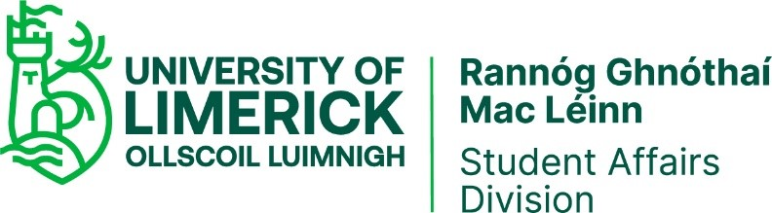

Communications Process

PURPOSE
The purpose of this process is to ensure that there is effective, succinct and clear communication both within the Student Affairs Division and with all internal and external stakeholders.

RESPONSIBILITY
Overall responsibility for this process lies with the Director, however all staff are responsible for maintaining good communications with all colleagues, students and stakeholders.

PROCEDURE
The Director is committed to ensuring that all staff has the opportunity to understand and contribute to the activities of the division. The communications process forms an integral part of this commitment.

Communication within Student Affairs
There are several strategies in place to ensure effective communication within Student Affairs.
- Division-Level Meetings: These include SA Management Team Meetings, one to one line manager-staff meetings, Quality Team Meetings, Quality Review Meetings, Unit team meetings.
- SharePoint: SharePoint is used as a central repository of information for all Student Affairs documents. All staff members have access to SharePoint. SharePoint sites are created for individual units/teams and for the Division.
- Open-door Policy: Informal communication is ensured by the Student Affairs Division’s open-door policy. Staff members are free to drop into any office at any time. The Director also has an open-door policy for all staff.
- Regular email bulletins: The Director sends regular email bulletins (at least twice per month) to all staff in the division to advise of staff joining / leaving, news items, project updates, and policies or procedures of relevance to the division.
- Annual divisional meeting: This takes place in January each year and focuses on reviewing the Quality Management System, as well as a general review of the year just passed and plans for the coming year, in line with the division’s strategic implementation plan.
- Other: In person or online divisional meetings are held as/when required to discuss issues of important to all staff in the division.
Communication with Internal Stakeholders
- Website: Student Affairs website ensures ongoing awareness by all key stakeholders of the activities undertaken by the division. The website outlines the roles and responsibilities of staff and services offered by each unit. The website also includes a customer feedback section which allows both internal and external stakeholders to provide feedback on any elements of service provision.
- Outside of face-to-face interaction, the division communicates with internal stakeholders through email, telephone, SMS messaging, social media and printed publications. An annual newsletter promoting the work of the division, its students and its people is developed and disseminated by the Quality Team.
- UL Connect: UL Connect is a dedicated platform for collaboration, information and knowledge sharing for staff to provide a better and more engaging experience at work.
- The internal stakeholders that Student Affairs Division engages with includes faculty/academic departments, professional support departments within UL, and UL’s two students’ unions.
The Director regularly submits a written report on division activities and issues arising to the Provost Deputy President General Management team (PDPGMT) meeting and communicates relevant information from the PDPGMT meetings at SA Management Team meetings.

Communication with External Stakeholders
The website is used as a key communication tool for both internal and external stakeholders. The Division communicates with external stakeholders by email, telephone, SMS messaging, social media, printed publications and formal advertising. Key external stakeholders to Student Affairs Division include, but are not limited to, the following:
- External higher education colleagues
- Other educational organisations and schools
- Voluntary, community and arts organisations
- Guidance services
- Parents, families and guardians
- State agencies and funding bodies
Stakeholder requirements and feedback are identified at Divisional level, via the Division’s online customer feedback link, as well as via University of Limerick survey and external national surveys. Stakeholder requirements and feedback are also identified at unit level via formal evaluations of unit services and both formal and informal unit feedback mechanisms (e.g. feedback cards, focus groups, informal consultation, emails etc).

Closing the Feedback Loop
For communication to be effective, it must be a cyclical and reflective process. Student Affairs are advocates of closing the feedback loop. This is done in several ways:
- Collating customer feedback on a central customer feedback log
- Responding directly to customers who have provided their contact details with their feedback
- Review of customer feedback by the Quality Team and actions arising from identified feedback themes
- Publication and dissemination of annual reports on service activity, including customer input
- Publication and dissemination of survey reports

COMPLAINTS
Formal complaints regarding the activities of the Student Affairs Division are dealt with through the University’s complaint process and procedures.
There is also a process within SA Customer Feedback procedure for dealing with complaints: Customer Feedback process (complaints)

DOCUMENTATION
SA Division Committee membership
SA Division ezine

RECORDS
Student Affairs Division ensures that webpage content is current and up to date. SharePoint is used as a central repository for all division- and unit-level documentation. Individual PCs/laptops are backed up to an ITD (Information Technology Division) managed server. Student Affairs Division is governed by UL’s Records Management and Retention Policy. Any personal data that is used as part of this process is processed in accordance with the General Data Protection Regulation (GDPR) / Data Protection Acts 1988-2018 and the University of Limerick Data Protection Policy.

PROCESS VERIFICATION
Evaluation of the Communications Process effectiveness is carried out using internal and QMS (Quality Management System) audits. Changes to the process are put in place as required and as appropriate.

REVISION HISTORY
Revision No. | Date | Approved by: | Details of Change | Process Owner
1 | Sept 13 |  | Initial Release | Director SA
2 | Jan 14 | Quality Team meeting 11/03/2014 | Inclusion of Quality Team Meetings and information on identifying stakeholders requirements
3 | Apr 16 | Quarterly Quality Review 10/05/2016 | Minor edits to text and inclusion of link to Quality Manual in Sharepoint
4 | Aug 23 |  | Process reviewed and updated to include QSU revised process templates

