Access Office Business process

PURPOSE
The Access Office (AO) is one of 11 units within the Student Affairs division and its purpose is to provide a range of pre/post entry supports to students who are under the age of 23 who enter the University through one of two Access routes, The Higher Education Access Route and the Access to University Course. The Academic Registry division operations department, in matters relating to Student Record Data Governance, Student Affairs department in relation to the Quality Management System, resource planning, and policy, support the Access Office. The Access Office works in line with the Student Affairs Customer Charter to deliver the Student Affairs service model and effective communications.

There are two principal areas of support, which inter-connect within the Access Office:

- Pre-entry/ widening access and participation:

The AO works in collaboration with a wide range of community and education partners focusing on confidence building and aspiration raising within the context of education from primary through to third level for prospective students, promotes UL (University of Limerick) undergraduate programmes and process applications from students from Socio-economically disadvantage backgrounds on the Access to University Course (AUC). The team engages with other universities, Guidance Counsellors, Schools, and community groups to take part at various career fairs and exhibitions throughout Limerick. In addition, they provide information and support to prospective undergraduate students, parents and schools as well as facilitating orientation and enrolment.

- Post-entry/widening access and participation:
The AO manage the maintenance of all records for Access students, (personal and academic) to include, Socio-economic status, Course selection, module selection, module grading, progression, and results during their programme in collaboration with the Academic Registry division. In addition, they support the advertisement, recruitment, assessment, and selection for the Access to University Course (AUC). The team engages with course directors, heads of departments, scheduling coordinators and module leaders to produce interview, module, and examination timetables as they relate to Access to University Course (AUC) students. The team works closely within the Student Affairs division including the Chaplaincy Service, Counselling Service, Student support service, Disability support services , Community Liaison Office, the Student life officers to manage and administer the mentoring, personal support opportunities and deliver best experience for pre/post entry supports to Access students in line with the student affairs mission.

RESPONSIBILITY
Overall responsibility for the process is held by the Access Officer. All Access Office staff are responsible for implementing the associated procedures.

PROCEDURE
The primary procedures associated with delivery of the above services include.

The Higher education Access Route
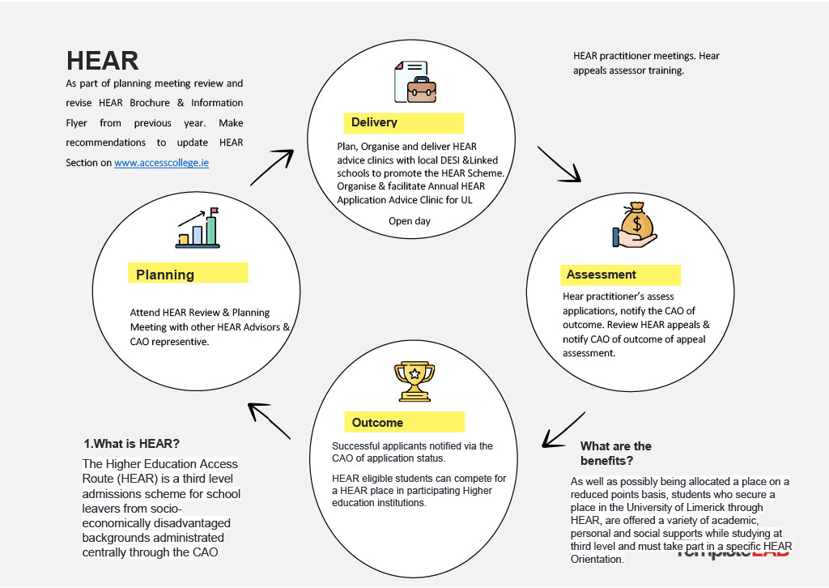

The Transition to University Course – Specific HEAR (Higher Education Access Route) Orientation
- Review and revise the Transition to University Course.
- Recruit Student Leaders and Tutors via online application form; applicants are called for interview and notified of outcome.
- Bookings regarding accommodation, (If on-campus option available) catering services, tutors, etc.
- Plan course platform in person/ Sulis/ Brightspace (Currently online due to late LC results)
- Academic Registry to notify AO of offers made to HEAR eligible students
- AO Send email registration link to HEAR eligible applicants who have been offered a place in UL.
- Once offers have been accepted AO contact students to confirm attendance.
- Deliver Transition to University Course. (Currently online due to late LC results)
- Carry out an Evaluation of the Course. (Refer to Qualtrics survey questionnaire in TUC Folder).

The Student Assistance fund
The Student Assistance Fund supports students who are experiencing difficulty in meeting the day-to-day expenses associated with attending college, or who meet unforeseen circumstances resulting in short or longer-term financial difficulties, (e.g., family difficulties, bereavement, accidents, or health problems).
- Agree online e-form layout and closing date for applications for distinct categories of students with new SAF (Student Assistance Fund) Committee.
- Carry out online form changes in collaboration with ITD (Information Technology Division)
- Application window open & completed application received.
- Applications processed by assigned assessors and decisions made.
- Payments made.
- Subject to funding availability, committee open to new applications.
- Final payments made for academic year.

Scholarships
- Review and revise the process with foundation/relevant department
- Populate database file with eligible applicants.
- Shortlist applicants based on agreed criteria.
- Assess applicants to determine eligibility for scholarship.
- Attend Steering Committee Meetings to discuss applications and award scholarships

Graduate Entry Medical School Scholarship Assessments
- Review and revise the process
- Create Database file for applicants.
- GEMS (GRADUATE ENTRY MEDICAL SCHOOL) populate database file.
- Forward file to Insight Coding to determine Socio-Economic Group (SEG).
- Financially assess applications to determine eligibility for scholarship.
- Attend Steering Committee Meetings to discuss applications and award scholarships.

Access to University Course
The Access to University Course is a pre-entry course for students under the age of 23 who meet the socio-economic criteria in accordance with The Higher Education Access Route. AUC is advertised, assessed, and delivered by the Access office in UL. Its purpose is to provide a range of pre/post entry supports to students in pursuance of their undergraduate degree. Its operation includes:
- Preparation/ Publication/Advertisement
- Application & Assessment Process
- Organisation, Creation, and delivery of AUC Course

Access student Volunteer Programme
The Access Volunteer Programme builds on the recognition that role models are an important feature of any young person's life. The programme recruits and trains Access students to become Ambassadors for the promotion of higher education for several Access programme. Its main procedures are:
- Advertise for mentors
- Deliver mentoring training in conjunction with Student Counselling.
- Mentors allocated mentee
- Hold “refresher” training for mentors.
- Hold match up session for Mentors and mentees.

Second-level access co-ordinator programmes
UL Access Office Second-level school activities are carried out with Higher Education aspiration raising in mind. The AO works in partnership with DEIS (Delivering Equality of Opportunity in Schools) (Delivering Equality of Opportunity in Schools) & Linked schools across Limerick city and county. Its main procedures are:
- Look to the Future
- Broadening horizons
- Orientation days
- Shadowing days

Academy for Children
The goal of the Academy is to encourage and support primary school children in local DEIS schools to reach their full potential and begin their journey onto higher education. Its main procedures are:
- In school ambassador programme
- Bespoke programme
- Parent & Guardian programme
- Exploration days
- College awareness week workshop
- Graduation from academy

Destination College (PATH 3)
The Destination College Programme works in partnership with local secondary schools, education providers and community-based projects to ensure that students from socio-economic disadvantaged backgrounds have the opportunity and support to fulfil their educational potential and aspirations by breaking down the barriers that impede upon their access to, and participation in, 3rd level education. Its main procedures are:
- In school/community &Alumni mentoring
- Parent & Guardian support programme
- In school/community transition programme
- Easter revision courses

DOCUMENTATION

You can view our Working Guidelines associated with the above KBP’S .

RECORDS
Records are held by Access Office for the period defined by individual processes. All members of staff operate in accordance with the University’s Records Management and Retention Policy. Any personal data that is used as part of this process is processed in accordance with the General Data Protection Regulation (GDPR) / Data Protection Acts 1988-2018 and the University of Limerick Data Protection Policy.

PROCESS VERIFICATION
Evaluation of the Access Office KBP effectiveness is carried out using internal and QMS (Quality Management System) audits. Changes to the process are put in place as required and as appropriate

REVISION HISTORY

Revision No. | Date | Approved by: | Details of Change | Process Owner
1 | 26/09/2019 |  | Initial Release | Access Officer
2 | 26/09/2019 |  | Amendments to Process B & C to reflect new online presence and changes to dates due to restructure of Academic year. | Access Officer
3 | 22/09/2023 |  | Process reviewed and updated to include QSU revised process templates. | Access Officer

