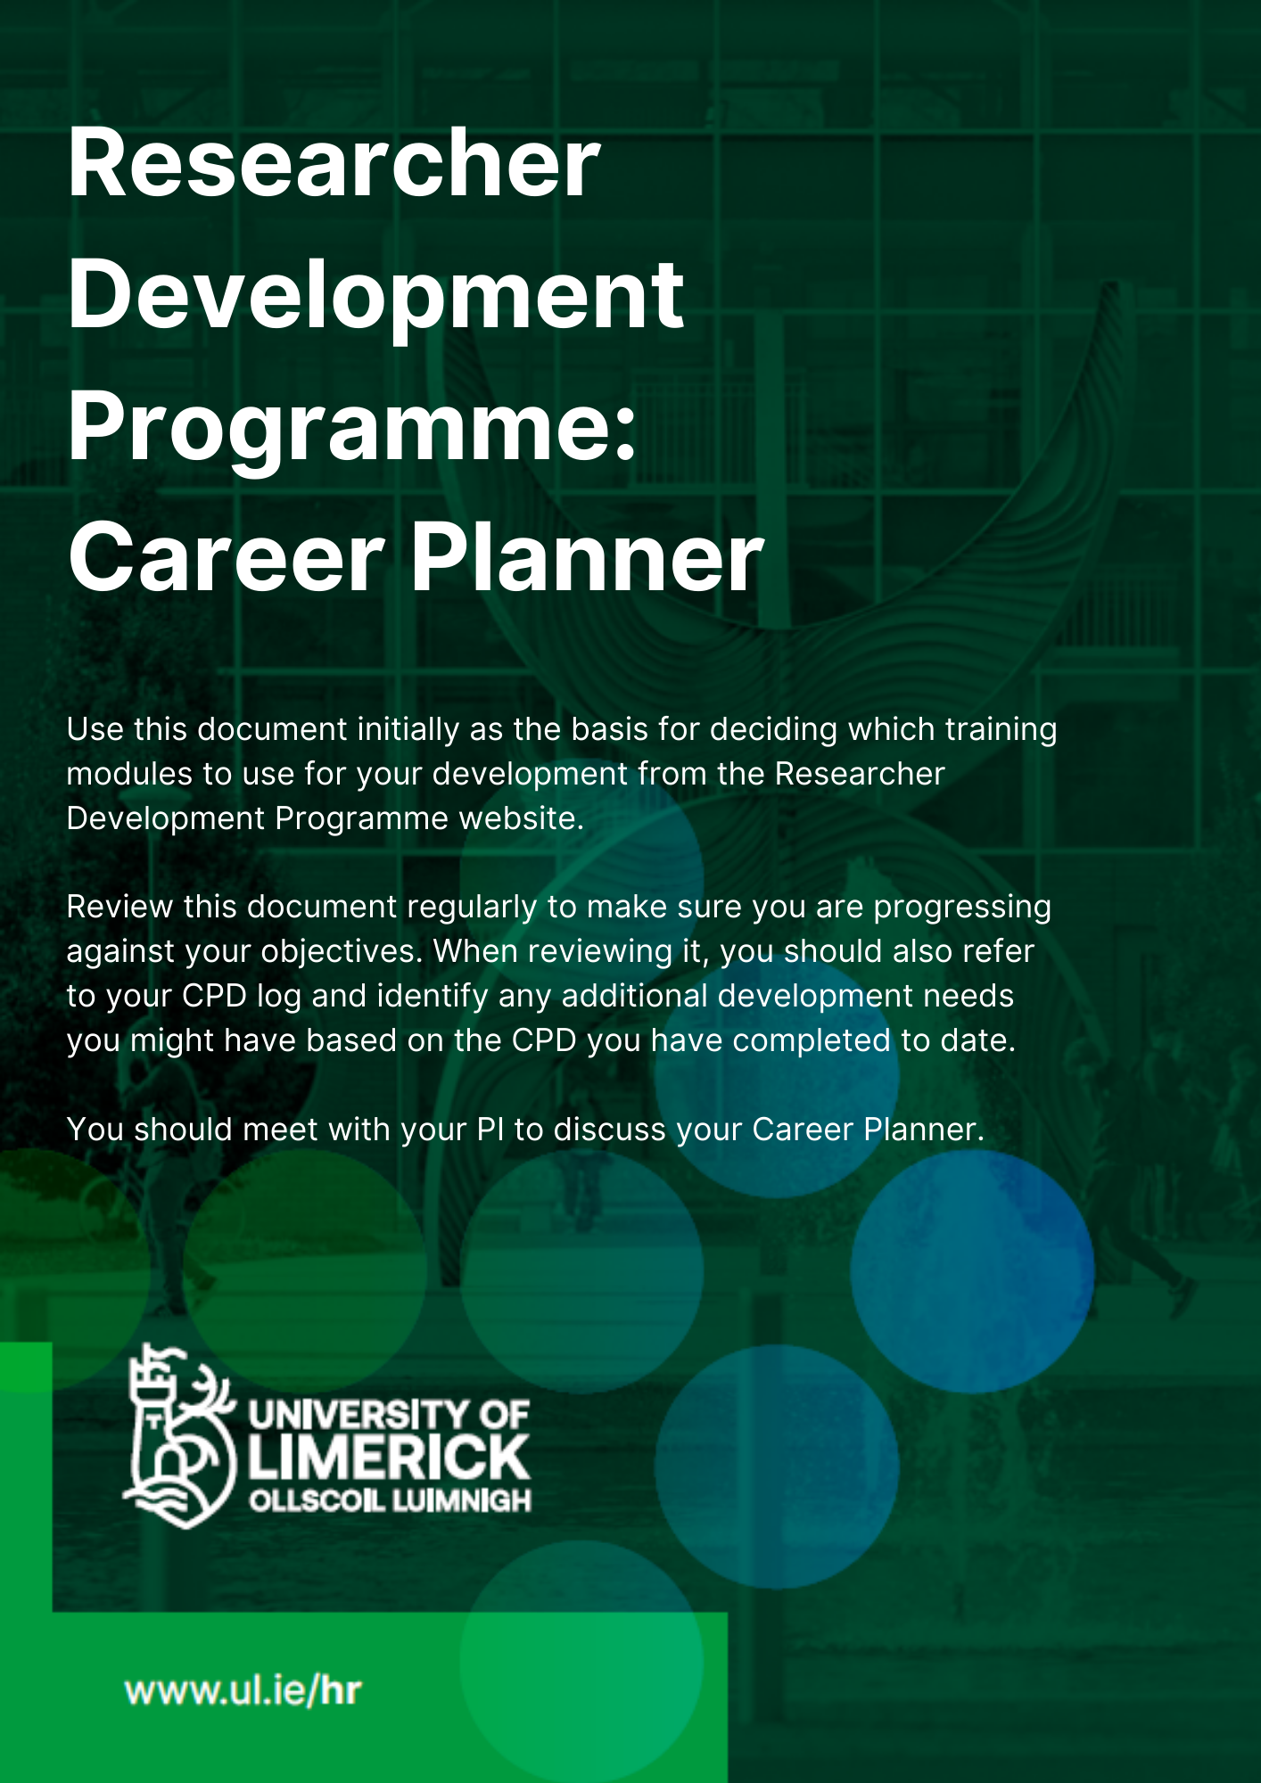

Section 1: Employee Details
EMPLOYEE NAME |  | JOB TITLE |  | START DATE
EMPLOYEE STAFF NUMBER |  | DATE OF LAST REVIEW (IF APPLICABLE |  | FACULTY/DIVISION
NAME & JOB TITLE OF PRINICPAL INVESTIGATOR |  | PERIOD COVERED BY THIS DOCUMENT |  | DEPARTMENT/UNIT

Section 2: Objectives and Development Objectives for Forthcoming Year
2.1 Objectives for the forthcoming year
Please include your role objectives for the coming year ensuring that these are SMART (Specific, Measurable, Agreed/Achievable, Relevant/Realistic, Time-bound) objectives. These are objectives associated with your role on a day-to-day basis. In considering your role objectives, you should ensure you have reviewed your Division/School/Department/unit objectives that are relevant to your role. Your objectives should align with those of your work area.

Objective | Action(s) | Target completion date | What might success look like? | Identify the Strategic Goal/Core Value to which objective is relevant, if applicable.

Please copy and paste additional rows if you have further objectives.

2.2 Development Objectives
2.2.1 Summary of aspirations, plans and personal/professional development needs for forthcoming year and beyond
Summarise below your aspirations, plans and personal/professional development needs.
Longer-Term Aspirations/Plans (5 years). This section should reflect your career aims beyond your current role.

Aspirations for Coming 12 Months. Using the indicators below, please identify your short-term career objectives.
- Research Activities

- Research Outputs

- Skill Development (The Skills Audit in Section 3 may be of assistance here)

- Other objectives

Section 3: Skills Audit
This skills audit should be used to inform what development opportunities the reviewee wishes to choose from the Researcher Development Programme menu. All the skills listed are linked to a domain on the European Competence Framework for Researchers (“ResearchComp”). ResarchComp establishes a common language and a common understanding of researchers’ transversal competences. Researchers can identify the competences that can foster interoperable careers in relevant socio-economic sectors and will be able to assess which ones they already master and with what proficiency level, and which ones deserve additional efforts, with clear benefits for their career and employability.
By completing this self-reflection once per year, the reviewee can assess their progress against the skills in each domain. Together with their manager, they should discuss the skills noted as requiring improvement. This discussion should conclude with the identification of 2 or 3 skills the reviewee should focus on for the upcoming year. These skills should then be included when completing section 4.2.2 of this form.
The Development Need Rating (1 = no requirement for development, 5 = strong requirement for development) should be used judiciously. It is designed to support the reviewee and their manager have a conversation about development opportunities, particularly as that relates to the competences that will support the reviewee in their role. In the ResearchComp each domain is broken down into 4 different levels: foundational, intermediate, advanced, and expert. Key descriptors are used at each level and these descriptors can be used to help inform development requirements for reviewees.

Section 3: Skills Review
This skills audit should be used to inform what development programmes you wish to choose from the Researcher Development Programme menu.
ResearchComp | Development Need  (1=no requirement for development:  5 = strong requirement for development)
Domain 1: Managing Research
 | 1 | 2 | 3 | 4 | 5 | Comments
Mobilise Resources
Manage Projects
Negotiate
Evaluate Research
Promote Open Access Publications
Domain 2: Making an Impact
Participate in the publication process.
Disseminate results to the research community.
Teach in academic or vocational contexts.
Communicate to the broad public.
Increase impact of science on policy and society.
Promote open innovation.
Promote the transfer of knowledge.
Domain 3: Self Management
Manage personal professional development.
Show entrepreneurial spirit.
Plan self-organisation.
Cope with pressure.
Domain 4: Cognitive Abilities
Abstract thinking
Critical thinking
Analytical thinking
Strategic thinking
Systemic thinking
Problem solving
Creativity
Domain 5: Working with Others
Interact professionally
Develop networks
Work in teams
Ensure wellbeing at work
Build mentor-mentee relationships
Promote inclusion and diversity
Domain 6: Managing Research Tools
Manage research data
Promote citizen science
Manage intellectual property rights
Operate open source software
Domain 7: Doing Research
Have disciplinary expertise
Perform scientific research
Conduct interdisciplinary research
Write research documents
Apply research ethics and integrity principles

3.2 In this section, consider development objectives relative to the Skills Audit undertaken in Section 3 above, and the competencies associated with the reviewee’s role. These are objectives which will complement and support you as you go about your role on a day-to-day basis, and which will contribute to your overall goals noted in section 4.2.1 above. Identify at least two skills for developmental focus in the coming 12 months. Please copy and paste additional rows if you have further development objectives.
How to use this table.
For example, the reviewee might want to learn about contributing to funding applications. The development need might be “I would like to learn about funding applications and support my PI by contributing to same”. The associated skills is Mobilise Resources and the type of development might be attend a writing for funding applications course. The reviewee can suggest a timescale, such within the next 12 months, and they can then take that on and seek out relevant courses.
Development Need | Associated Skill/Objective | Type of development | Timescales | Who is responsible? | Further comments

Final sign off: To be completed by Researcher and Principal Investigator once the meeting has taken place and the form has been completed.
Researcher’s Signature:
Date (dd/mm/yyyy):
Principal Investigator’s Signature:
Date (dd/mm/yyyy):

