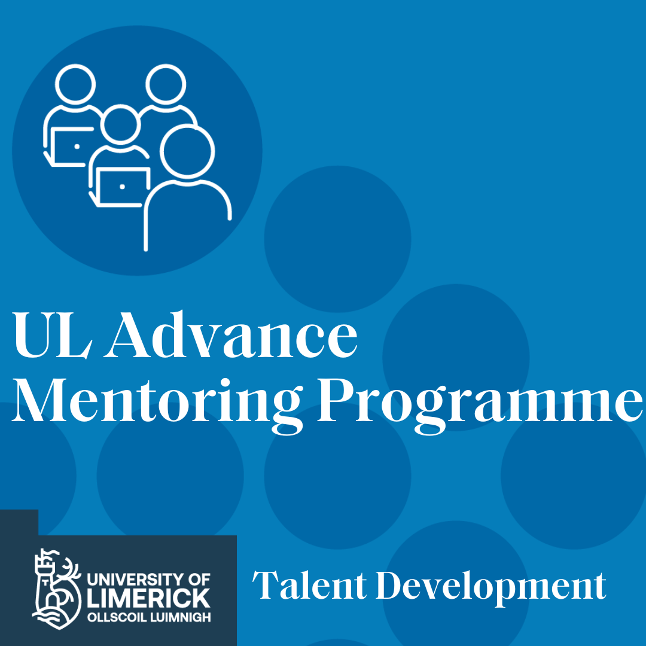

Contents

Mentoring in the University of Limerick 2

What is Mentoring? 3

Why become a Mentee? 3

Why become a Mentor? 4

Audience 5

Support 5

Guidelines 6

What is it? 6

The Aims of UL Advance are: 6

How it works 7

Mentoring Relationships 8

Confidentiality Statement 8

Evaluation 8



## Mentoring in the University of Limerick

Throughout our lives we meet challenges, that had we had the support of a Mentor, we perhaps would have done things differently. Have you ever asked yourself any of the following questions?

* Where can I get advice on new responsibilities?

• What opportunities for promotion exist in the University?

• How can I apply for a different post?

• How can I successfully apply for funding?

• Is job-sharing for me?

• How can I get a grip on UL culture?

• I am finding my role challenging, can anyone offer me advice?

A Mentor could possibly help you.

The aim of the **UL Advance Mentoring** programme is to provide an opportunity through which experiences can be shared on a one-to-one informal basis, thus providing support to colleagues in the early stages of their careers and within their own department.

UL Advance builds upon the mentoring culture and climate of UL. This programme is administered by your department and supported by HR Talent Development.

## What is Mentoring?

Mentoring is a trusted staff development support in the workplace. It provides a safe and supportive environment for the mentees to assist them in their careers and in psychosocial functioning in the workplace. The relationship between mentee and mentor is collegiate and collaborative and provides benefits to both the mentor and mentee.

## Why become a Mentee?

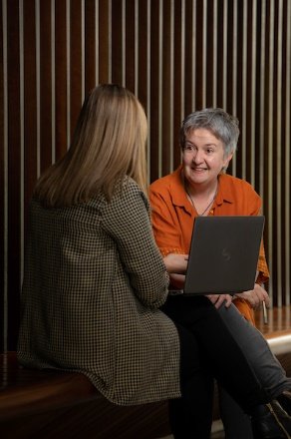Have you ever wished you knew someone who had already experienced what you are going through? Do you want to learn from others’ experience and perhaps their mistakes? Do you want to discuss issues with another faculty or department member? The University of Limerick is a large organisation and having a mentor can increase your informal knowledge of how things work here, broaden your perspective and help you ‘navigate’ the UL maze. Depending on what you want, as mentee, mentoring will give you the opportunity to receive support while you take responsibility for your career/personal goals. Becoming a mentee is entirely voluntary, but highly recommended to support your career development and personal growth.

## Why become a Mentor?

Many employees struggle with answering this question. Mentoring allows you to provide an insight, share experiences and ‘give something back’ so as to facilitate a colleagues development. Professional development of our colleagues is key to their success and contributes significantly to being the University we want to be – ambitious, collegiate and inclusive.  We all have a role to play in creating a culture where colleagues are supported to enable them to be their best.  The development of University of Limerick employees, through mentoring, will result in a more positive working environment. Mentoring gives staff an opportunity to support those colleagues who are facing similar challenges, within an agreed time frame. Depending on the focus identified by the mentee; mentoring will provide a forum for you to impart your career and/or personal knowledge and experiences. As a mentor you will also be challenged to understanding how and why the system works in this manner. The role of the mentor is to be an objective critical friend supporting and encouraging the mentee by sharing one’s own experience and institutional knowledge and encouraging the mentee to reflect on one’s own career and progress.

## Audience

The aim is to embedded mentoring in every faculty, department, and division in the University, however this will take time. For 2024/25 UL Advance will focus on those at the following grades across the University:

•Administrators

•Senior Administrators

•Assistant Professors

•Associate Professors B.

•Postdoctoral Researchers

Being mentored is entirely voluntary. You are free to opt-out of mentoring.

## Support

Training is provided for both mentees and mentors by HR Talent Development. In addition, support is provided through your faculty and department.

## Guidelines

### What is it?

* UL Advance Mentoring is a Mentee-led relationship between two people within the same department.
* Mentoring is a confidential process.
* Pairing is done by the Head of Department/line manager, as they know their own people best.
* At any time either party may withdraw from the relationship.
* Mentoring does not replace more formal structures already in place e.g. Performance development reviews, probation meetings or formal reporting relationships.

### The Aims of UL Advance are:

* Helping Mentees to build self-confidence.
* Sharing knowledge, skills and experience.
* Increase departmental networking.
* Help with career planning.
* Encouraging inclusivity across the University.

Discussion topics may include:

•Career development

•Skills and competencies

•Understanding UL

•Work life balance

•Challenges in your role

•Networking possibilities

•Strategic Thinking

•Leadership

•Teaching

•Research

•Personal Development

### How it works

* Heads of Department and Line Managers are best placed to pair mentors and mentees within their own department.
* Mentors and mentees will undertake a short training programme provided by HR Talent Development.
* At their first meeting ,the mentor and mentee will complete a Mentoring Agreement document which sets out the ground rules for their meetings.
* Mentors and mentees commit to meeting for 3 * 1-hour meetings over the course of their mentoring relationship.
* New mentoring pairs will be established each academic year allowing for a varied experience for both mentor and mentee . This also avoids the mentee becoming dependent on any one mentor.

## Mentoring Relationships

The mentoring relationship is mentee-led and therefore the mentee needs to be committed to the relationship and follow-through on agreed actions. He / she needs to keep in touch with the mentor and articulate their needs in relation to the Mentoring relationship. The mentee is responsible for keeping in contact with the mentor, as agreed in the Mentoring Agreement document.

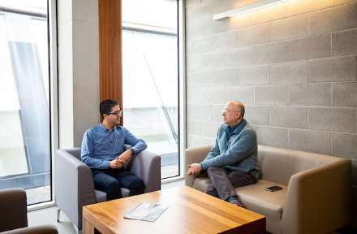

The mentor’s role is to help the mentee develop his / her career and life goals while working in the University and to support the mentee in meeting his / her objectives.

Mentor/mentee relationships will not extend beyond 3 * 1-hour meetings.

## Confidentiality Statement

•Mentees and mentors should note that the professional and personal information shared during mentoring is confidential to the pairs involved, and should remain so, even when the mentoring relationship has ended.

•When discussing general views on mentoring, care should be taken that specific individuals cannot be identified.

•Any professional and/or personal information shared, discussed or disclosed during mentoring shall be processed in compliance with the Data Protection Acts 1988 and 2003.

## Evaluation

A short survey will be issued to all participants of UL Advance to collect feedback.

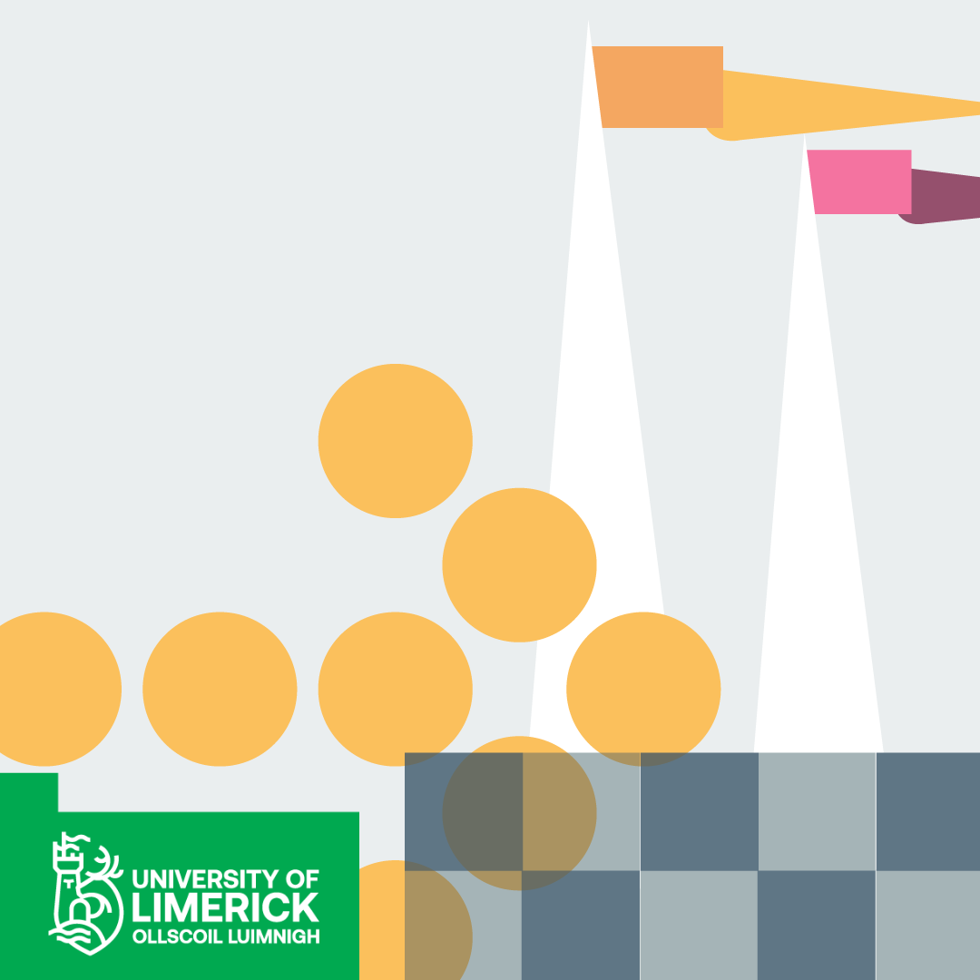

**UL Advance Mentoring Programme**

**For all enquiries, please email**

**hrtalentdevelopment@ul.ie**

**University of Limerick,**

**Limerick, V94 T9PX,**

**Ireland.**

**www.ul.ie**