User Guide: How to Use Employee Requests on CoreHR Portal
Introduction
Employee Requests will allow you to submit requests for various types of leave or special arrangements. This guide will walk you through how to use the Employee Requests feature for the following categories:
- Additional Unpaid Maternity Leave
- Compassionate Leave
- Force Majeure
- Leave For Medical Care
- Marriage Leave
- Maternity Leave
- Parents Leave
- Part-Time Working Application
- Paternity Leave Application
- Shorter Working Year
- Unpaid Compassionate Leave

Table of Contents
- Accessing the CoreHR Portal
- Navigating to Employee Requests
- Types of Employee Requests
- Submitting a Request
- Tracking and Managing Your Requests
- Notifications and Approvals
- FAQ’s
- Field Definitions.

1. Accessing the CoreHR Portal
To begin using the CoreHR Portal:
- Open your web browser.
- Enter the CoreHR Portal URL: Login | People XD (28.0.116)
- Log in using your Username (firstname.lastname) and Password (Same as UL Email and Desktop Password).
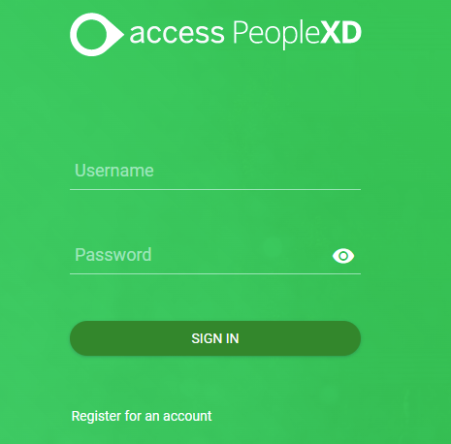
Once logged in, you'll be directed to the CoreHR Portal's homepage.

2. Navigating to Employee Requests
To access the Employee Requests section:
- From the homepage, locate the "Employee Dashboard" tab on the main navigation menu on the top left of the screen.

- Select My Time from the menu on the left.
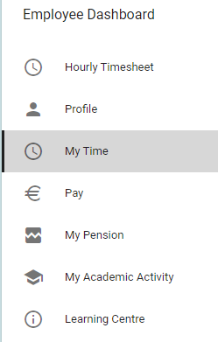
- Scroll down to view the "Employee Requests" widget.
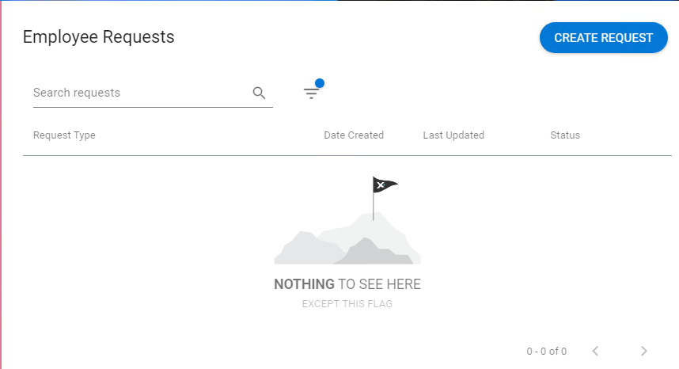

3. Types of Employee Requests
In the Employee Requests section, you can submit the following types of requests:
- Additional Unpaid Maternity Leave: Request for additional unpaid leave beyond the standard maternity leave.
- Compassionate Leave: Request for leave due to personal or family emergencies, such as the death or illness of a close family member.
- Force Majeure: Request leave for unforeseen circumstances beyond your control (e.g., natural disasters or emergencies).
- Leave For Medical Care: Submit a request for leave to undergo medical treatment or recovery.
- Marriage Leave: Request leave for your own wedding.
- Maternity Leave: Submit a request for maternity leave after the birth of your child.
- Parents Leave: Request leave for parents to care for children after birth or adoption.
- Paternity Leave Application: Submit a request for paternity leave following the birth of your child.
- Part-Time Working Application: Request a reduction in working hours.
- Shorter Working Year: Request a temporary reduction in working hours for a specific period.
- Unpaid Compassionate Leave: Submit a request for unpaid leave due to personal or family emergencies where paid leave is unavailable.

4. Submitting a Request
Steps to Submit a Request:
- Click Create Request
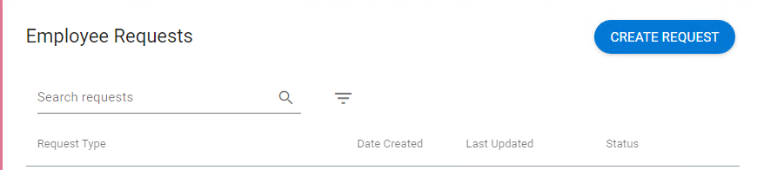
- Select the type of request you want to submit from the Request Type dropdown.
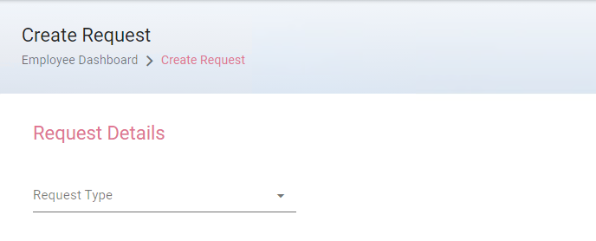

- Fill out the request form:
  - Additional Unpaid Maternity Leave: Specify the start and end dates of the additional leave and provide any necessary documentation (e.g., medical certificate).
  - Compassionate Leave: Enter the dates you require and provide the reason (e.g., family emergency).
  - Force Majeure: Enter the dates you are unable to work due to the exceptional event.
  - Leave For Medical Care: Specify the medical treatment or recovery period and the dates for leave.
  - Marriage Leave: Provide the dates of your wedding and any relevant details.
  - Other Leave Types: Similarly, enter the relevant dates and any supporting information as per the request type.
- Attach any required documentation (such as a doctor's note, marriage certificate, etc.) if prompted.

- Review your request to ensure all details are accurate.
- Click “Submit” to send your request for HR review.

5. Tracking and Managing Your Requests
After submitting your request, you can track its status:
- Navigate to the "Employee Requests" widget.
- You will see a list of all your submitted requests, including the status (e.g., Pending, Approved, Rejected).
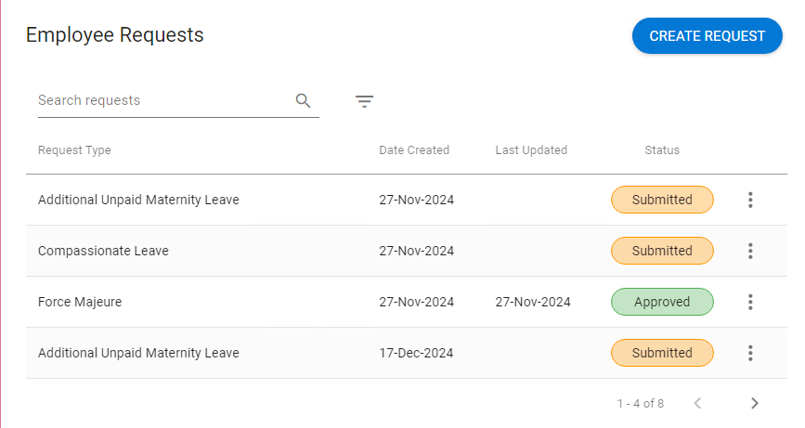
- Click the 3 dots on a request to view its details.
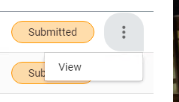

6. Notifications and Approvals
After submitting your request, you will receive notifications at key stages:
- Approval/Reject Notification: You will receive an email or in-portal notification when HR or your manager has actioned your request.
- Status Updates: If your request is under review or requires additional information, you will be notified of any changes.
- Document Review: If HR requires supporting documents (e.g., a medical certificate), you may be notified to upload additional files.
Notifications will keep you informed of any progress or required actions.

- Approving a Request
When a member of you team submits a request, you will receive an email notification from the system.
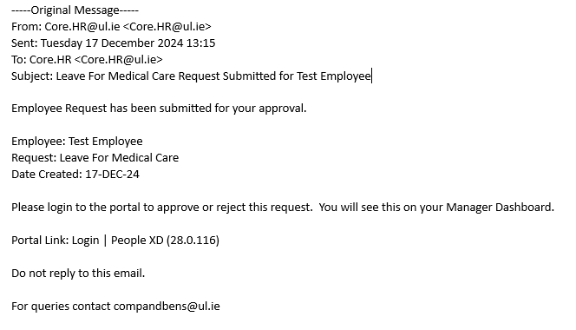

Proceed to the Approvals section of the Manager Dashboard.
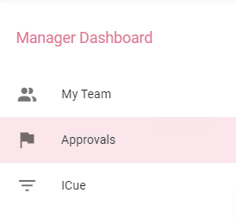
On the My Approvals Widget, click View on the request you want to action.

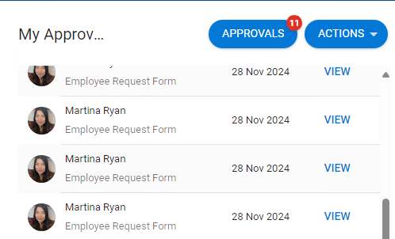

The next screen will show all details included in the request. To view any attached documents, click on View Details. To approve or reject, click on either button on the bottom right of the screen.

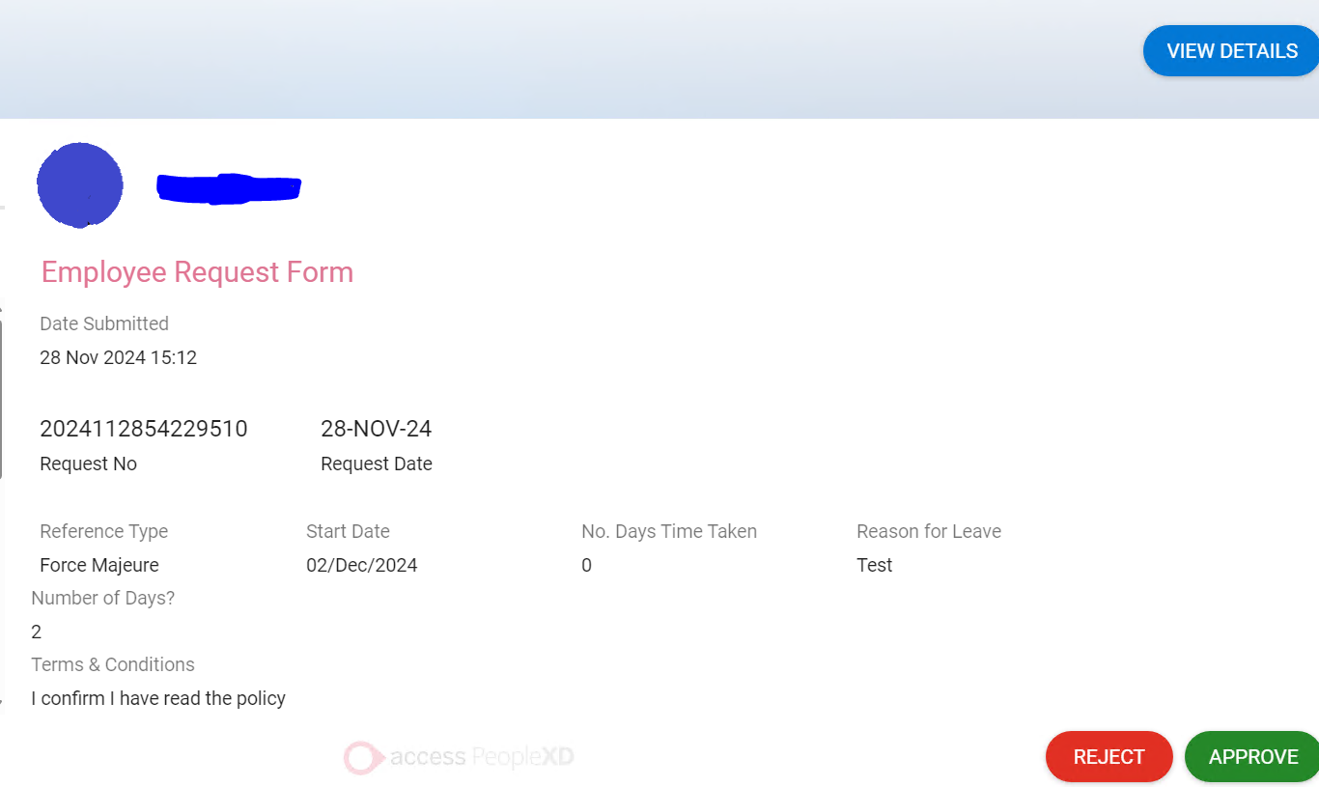

7. FAQs
1. What if I can't submit my request?
- Double-check that all required fields are filled out, including dates and reasons.
- Ensure that any necessary documentation (e.g., medical certificates or marriage proof) is uploaded.
- Contact HR for assistance if the issue persists. (CorePortalEmail@ul.ie)
2. How far in advance should I submit my leave request?
- For most requests, it's recommended to submit at least 2-3 weeks in advance, especially for long-term or specialized leaves (e.g., maternity or paternity leave).
3. Can I submit multiple leave requests at the same time?
- Yes, you can submit multiple requests, but each will be handled separately by HR.
4. How will I know if my request is approved?
- You will receive a notification (email & in-portal) indicating the approval status of your request.
5. What types of supporting documents are needed?
- Depending on the type of leave, documents such as a doctor's certificate, marriage certificate, or proof of emergency may be required.

- Field Definitions.
Additional Unpaid Maternity leave
Start Date | Date the unpaid leave will commence (as maternity leave must end on a Fri, unpaid ML should commence on a Mon)
No. of wks unpaid | Number of weeks unpaid ML the staff member wishes to take. Minimum 1 week, maximum 16 weeks
Personal Email | Staff members personal email address that they can be contacted on while on unpaid maternity leave (where necessary). This avoids the need to monitor their UL email while on leave
Terms & Conditions | The staff member must agree that they have read the maternity leave procedure prior to applying for the leave

Compassionate Leave
Start Date | Date compassionate leave will commence i.e. 1st day of leave
End Date | Date compassionate leave will finish i.e. last day of leave
Date of Bereavement | The date that the deceased passed away
Personal Email | Staff members personal email address that they can be contacted on while on compassionate leave (where necessary). This avoids the need for the staff member to monitor their UL email while on leave
Relationship | Relationship to the Deceased
Terms & Conditions | The staff member must agree that they have read the maternity leave procedure prior to applying for the leave

Force Majeure
Start Date | Date force majeure will commence i.e. 1st day of leave
No.Days time taken? | Number of Force Majeure days previously taken.
Reason for Leave | Explanation of why this leave is being applied for i.e. this leave is granted for urgent reasons
Number of Days | How many days leave are being applied for (between 1-5 days)
Terms & Conditions | The staff member must agree that they have read the force majeure procedure prior to applying for the leave
End Date | Date Force Majeure leave will finish i.e. last day of leave
Personal Email | Staff members personal email address that they can be contacted on while on force majeure leave (where necessary). This avoids the need for the staff member to monitor their UL email while on leave

Leave for Medical Care
Caree Address | The address of where the person who requires care is located
Relationship | The carer's relationship to the caree e.g. parent etc
Reason for Leave | Short explanation of why this leave is being applied for
Date From | Date Leave for Medical Care will commence i.e. 1st day of leave
Date To | Date Leave for Medical Care will finish i.e. last day of leave
Terms & Conditions | The staff member must agree that they have read the Leave for Medical Care procedure prior to applying for the leave
Personal Email | Staff members personal email address that they can be contacted on while on Leave for Medical (where necessary). This avoids the need for the staff member to monitor their UL email while on leave

Marriage Leave
Marriage Date | Date the staff member got married
Start Date | The date the staff member will commence marriage leave i.e. 1st day of leave
Duration of Leave | The number of days leave being applied for (1-5 days)
End Date | The date the staff member will finish marriage leave i.e. last day of leave
Terms & Conditions | The staff member must agree that they have read the Marriage Leave procedure prior to applying for the leave
Personal Email | Staff members personal email address that they can be contacted on while on Marriage Leave (where necessary). This avoids the need for the staff member to monitor their UL email while on leave

Maternity Leave
Maternity Start Date | The date that the maternity leave will commence i.e. 1st day of leave (always a Monday)
Attach Med Cert EDD | The staff member must attach a GP cert confirming their expected due date
Expected Due Date | The date the staff member is expecting their baby
Personal Email | Staff members personal email address that they can be contacted on while on Maternity Leave (where necessary). This avoids the need for the staff member to monitor their UL email while on leave

Parents Leave
Start Date | The date that Parents leave will commence i.e. 1st day of leave
No. of weeks | The staff member must confirm the number of weeks leave they are applying for (1-9 weeks)
Birth cert attached | The staff member must include a copy of the birth cert for the child in which the leave is being applied for
End Date | The date the staff member will finish Parents leave i.e. last day of leave
Terms & Conditions | The staff member must agree that they have read the Parents Leave procedure prior to applying for the leave
Personal Email | Staff members personal email address that they can be contacted on while on Parents Leave (where necessary). This avoids the need for the staff member to monitor their UL email while on leave

Part-time Working Application
Commencement Date | The date that the part-time working arrangement will commence i.e. the date that the staff member will begin working reduced hours/days per week
PT Wrkg hours sought | The number of hours the staff member is applying to work under the part time working arrangement i.e. 0.5FTE, 0.8FTE or Monday to Friday 9am – 12.30pm
Terms & Conditions | The staff member must agree that they have read the Part-time working procedure prior to applying for the leave
Is this a renewal? | Is the staff member applying for part-time working for the first time or are they renewing their current part-time working arrangement for another 12 months?

Paternity Leave
Due Date/DOB | The staff member must confirm the expected due date of their baby or if the baby is born, the staff member must confirm the child's date of birth
Dr's cert attached | The staff member must provide a GP cert confirming the expected due date of the baby
Start Date | The date that Paternity leave will commence i.e. 1st day of leave
End Date | The date the staff member will finish Paternity leave i.e. last day of leave
Terms & Conditions | The staff member must agree that they have read the Paternity leave procedure prior to applying for the leave
Personal Email | Staff members personal email address that they can be contacted on while on Paternity Leave (where necessary). This avoids the need for the staff member to monitor their UL email while on leave

Shorter Working Year
Start Date | The date that SWY will commence i.e. 1st day of leave
End Date | The date the staff member will finish SWY i.e. last day of leave
No. of weeks | The staff member must confirm the number of weeks leave they are applying for (2-13 weeks)
AL adjusted | The staff member must confirm that they are aware that their annual leave balance will be adjusted on a pro rata basis as a result of availing of SWY
Post approval | The staff member must confirm that they are aware that the dates of SWY leave cannot be altered/amended once applied for in accordance with the terms of the scheme.
Pension | The staff member must confirm that they are aware that SWY does not reckon for pension purposes
>12 months service | The staff member must confirm that they have completed 12 months service or more in the University before applying for SWY
Terms & Conditions | The staff member must agree that they have read the Shorter Working Year procedure prior to applying for the leave
Personal Email | Staff members personal email address that they can be contacted on while on SWY leave (where necessary). This avoids the need for the staff member to monitor their UL email while on leave

Unpaid Compassionate Leave
Start Date | The date that unpaid compassionate leave will commence i.e. 1st day of leave
End Date | The date the staff member will finish unpaid compassionate leave i.e. last day of leave
Date of Bereavement | The date that the deceased passed away
Number of Days | The number of days unpaid compassionate leave that the staff member is applying for
Relationship | The staff members relationship to the deceased
Terms & Conditions | The staff member must agree that they have read the Compassionate Leave procedure prior to applying for the leave
Personal Email | Staff members personal email address that they can be contacted on while on Unpaid Compassionate Leave (where necessary). This avoids the need for the staff member to monitor their UL email while on leave

